The website I chose to review was Craigslist (<https://nh.craigslist.org/>). In my opinion, the most glaring issue is the way the home page looks. It’s very cluttered, there is nothing to break up the various sections, and most of the text is the same color and size. When everything looks the same across the whole home page, it’s difficult to find what you’re looking for. Additionally, some text is a bit too small, which causes issues with accessibility.

When looking at the subpages, the website is slightly less cluttered. However, outside of the ‘for sale’ and ‘housing’ pages, there is still nothing to really break up the individual posts. This is especially true for pages such as the ‘services’ page, where there is not even space for an icon. This leads to the entire page being nothing but text, which again causes difficulty in finding things. The subpages also do not have a clear link back to the homepage.

Another issue with the Craigslist website is the responsiveness. While it does have a mobile site if your screen or window is small enough, at a certain point it goes back to the desktop version. This results in people who are using tablets, for example, being unable to see the full page without scrolling.

All of these problems seem fairly straightforward to fix. Adding images or simply spreading out the text a bit more would help with the pages that are cluttered, and fixing the responsive issue would require either changing the mobile version to activate on a larger screen size, changing the desktop version so that resizing the window also resizes the contents of the window, or simply creating an entirely different version of the website for tablet screens. I would also increase the font size in several places, and change the homepage link to be more clear.

The first usability heuristic by Jakob Nielsen is ‘visibility of system status’ (Nielsen). Craigslist does somewhat follow this principle, as it has a simple navigation system at the top of the page that shows where you are on the site.



The second usability heuristic is ‘match between system and the real world’ (Nielsen). This one is, again, followed for the most part. Since users themselves are the ones writing the listings, the listings can occasionally be difficult to understand.

The third usability heuristic is ‘user control and freedom’ (Nielsen). For most of the site, there is no need for undo or cancel buttons. The two exceptions I could find were on individual listing pages, and when creating a listing. On individual listing pages, you have the option to favorite, flag, hide, or share a listing. All of these have ways to undo or cancel the action, except for flagging. I could find no way to ‘unflag’ a listing. Additionally, when creating a listing, there is no cancel button. If you change your mind halfway through creating a listing, the only way out is to use the ‘back’ button in the browser, close the window, or click the (again, unlabeled) home button in the top left corner.

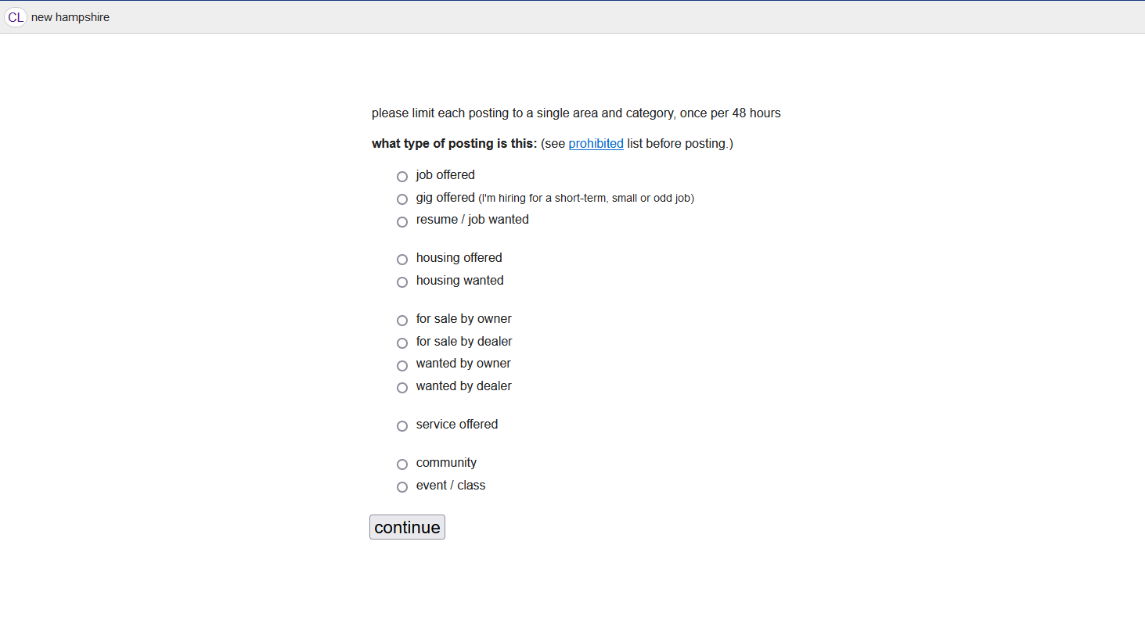

The fourth usability heuristic is ‘consistency and standards’ (Nielsen). Craigslist has good internal consistency, and fairly good external consistency. The exception is, again, individual listings, since users create the posts themselves and therefore are able to use their own words that might be different from words used across the rest of the site.

The fifth usability heuristic is ‘error prevention’ (Nielsen). As mentioned earlier, many links – especially on the homepage – are crowded together and look similar. Therefore, it’s very easy to click on the wrong one. Also as mentioned earlier, there is no way to undo a flag, there is no request for confirmation before it goes through, and there is no straightforward way to cancel creating a new listing.

The sixth usability heuristic is ‘recognition rather than recall’ (Nielsen). This is difficult to measure, considering both the lack of any kind of design on Craigslist as well as the fact that there is not much information that is necessary to recognize or recall in order to use the site. There aren’t really instructions on using the site anywhere other than the ‘help’ section.

The seventh usability heuristic is ‘flexibility and efficiency of use’ (Nielsen). Craigslist certainly does not follow this one, as there is no personalization or customization outside of the search function.

The eighth usability heuristic is ‘aesthetic and minimalist design’ (Nielsen). While Craigslist’s design could certainly be considered minimalist and pares the content down to just the bare essentials, in the end it just makes it more difficult to focus on the various elements. This defeats the purpose.

The ninth usability heuristic is ‘help users recognize, diagnose, and recover from errors’ (Nielsen). There are not many places where errors can occur; however, one such place is when creating a new listing. In this case, the error message is clear and concise, and the sections where errors occurred are outlined in red.





The tenth usability heuristic is ‘help and documentation’ (Nielsen). As mentioned earlier, there is a ‘help’ section, and barring the usual design issues it is easy to navigate. There are even screenshots in sections as needed to help users understand.

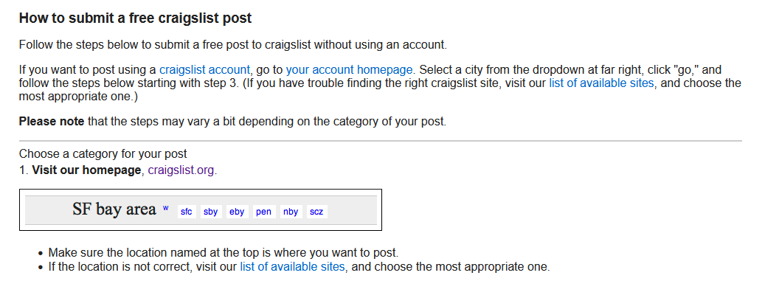

Works Cited

Nielsen, Jakob. “10 Usability Heuristics for User Interface Design.” *Nielsen Norman Group*, 24 Apr. 1994, www.nngroup.com/articles/ten-usability-heuristics/.